

《软件工程原理与应用》
系统设计报告
小 组 | 102 D 刘梦琳 阿依斯木巴特·哈依拉提 朱天雅 石煜堃
学院 | 计算机科学与技术学院/人工智能学院/软件学院
专业 | 计算机科学与技术
班级 | 1622102
游戏推荐系统

二〇二四年十一月

目录
一、引言 2
1、编写目的 2
2、背景 2
3、定义 3
4、参考文献 4
二、界面设计 4
1、Gameplayer类 4
2、Gamepublisher类................................................................................................................4
3、Administrator类..................................................................................................................4
4、 Gameinformation类 5
5、 Thumbsup类 6
6、 Comment类 6
7、 Collect类 6
三、事务逻辑设计 7
四、数据库设计 7

一、引言

1、编写目的
需求说明书目的是使用户和软件开发者双方对该软件有一个共同的理解，使之成为整个开发工作的基础。便于用户、开发人员进行理解和交流，反映出用户问题的结构，可以作为软件开发工作的基础和依据，并作为确认测试和验收的依据。
预期读者：软件设计者和测试者。

2、背景
说明：
- 待开发的软件系统的名称：游戏推荐系统
- 本项目的任务提出者：刘梦琳 阿依斯木巴特·哈依拉提 朱天雅 石煜堃；
- 本项目的任务开发者：刘梦琳 阿依斯木巴特·哈依拉提 朱天雅 石煜堃；
- 用户： 需要游戏推广的企业、需要推荐游戏的玩家 。
- 实现该软件的计算中心或计算机网络：南京航空航天大学计算中心。

3、定义
名称 | 说明
账号 | 用户注册时登记的用户名（手机或邮箱）及密码
用户分类 | 用户、游戏发布者、管理员
账号管理 | 用户与管理员都可通过该模块对自己的信息进行增加、查询、修改、删除操作，分别对应注册、登录、修改用户信息及找回密码、注销，管理员拥有对所有用户的信息进行各项操作的权限
用户偏好收集 | 用户登录后，回答问题，管理员收集用户偏好
推荐游戏 | 管理员根据收集好的用户偏好给用户推荐游戏
游戏发布管理 | 游戏发布者填写需要发布的游戏信息后送审
修改游戏信息 | 发布该信息的游戏发布者修改游戏信息后送审
查看游戏信息 | 所有用户均可查看已发布的游戏信息，并通过游戏名称查询特定游戏信息
审核游戏信息 | 管理员审核游戏发布者发布的游戏信息，可以选择通过或退回
撤回游戏推荐 | 发布游戏的游戏发布者可以撤回游戏推荐，并填写结束游戏推荐信息，审核通过后，删除与该游戏相关的信息
审核撤回信息 | 管理员审核游戏发布者提交的结束游戏推荐信息，可以选择通过或退回
收藏游戏 | 用户可以收藏感兴趣的游戏
取消收藏游戏 | 用户可以取消已收藏的游戏
查看收藏游戏 | 用户可以查看已收藏的游戏
点赞评论 | 用户可以给认同的评论点赞
取消点赞评论 | 用户可以取消给评论点的赞
查看点赞的评论 | 用户可以查看点赞的评论
发表评论 | 用户可以在游戏信息下发表评论
查看评论 | 用户查看其他人或自己发布过的评论
审核评论 | 管理员审核用户发表的评论，可以选择通过或退回
删除评论 | 发布该评论的用户或管理员可以删除评论

4、参考文献
编号 | 参考资料 | 作者
1 | 《软件工程（第四版）》，高等教育出版社，2019 | 齐治昌等
2 | 《构建之法现代软件工程（第二版）》，人民邮电出版社，2017 | 邹欣
3 | 《Test-Driven Java Development》，Packt Publishing，2015 | Viktor Farcic、Alex Garcia

二、界面设计

1、 Gameplayer类
signupOrdinaryUser.html | 玩家注册页面

web:
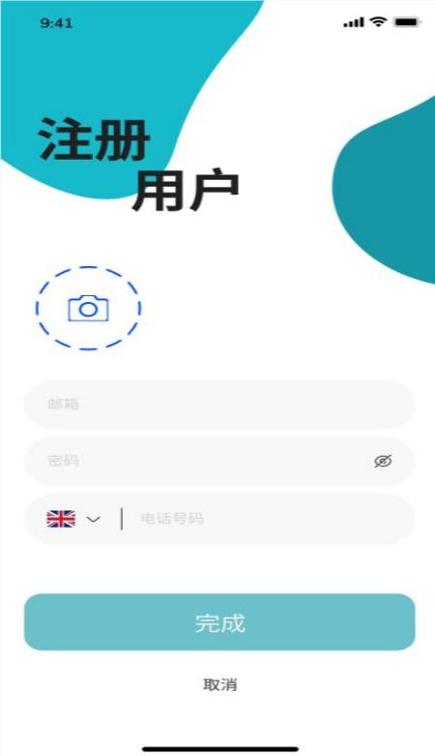

app:


signin.html | 登录页面
web:
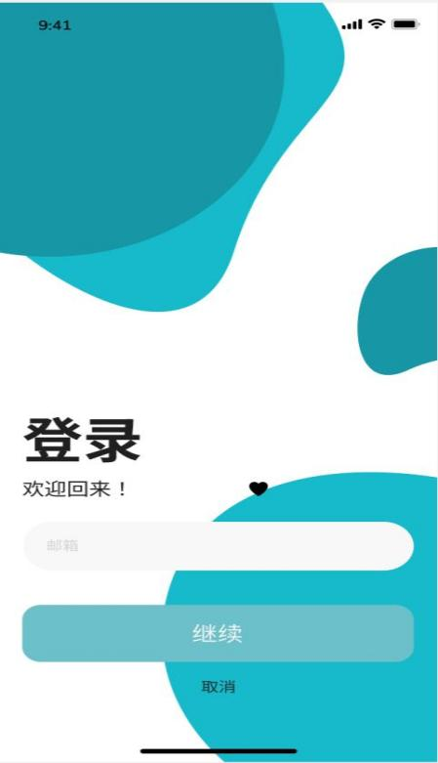
app:


index.html | 首页
web:
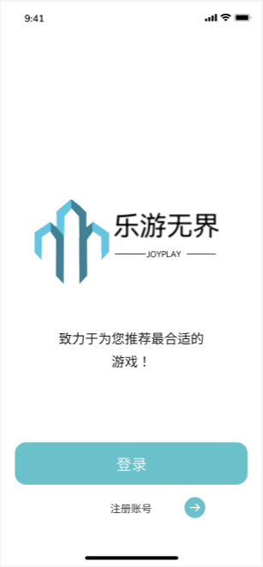
app:


getUserInfo.html | 查看个人信息页面
changeUserInfo.html | 修改个人信息界面
changePassword.html | 修改密码
cancelUser.html | 注销账户页面
forgetPassword.html | 密码找回页面
web:
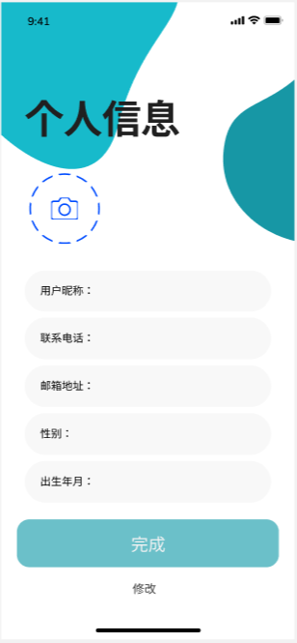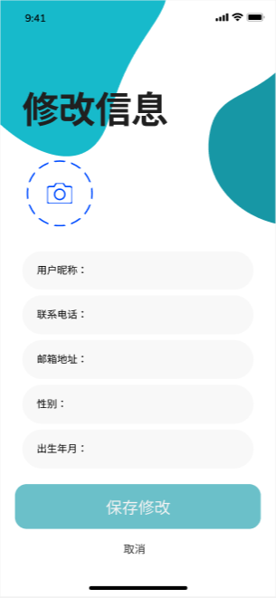
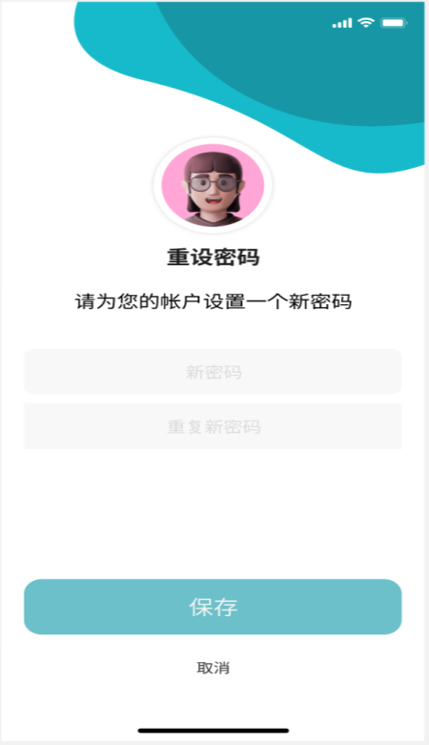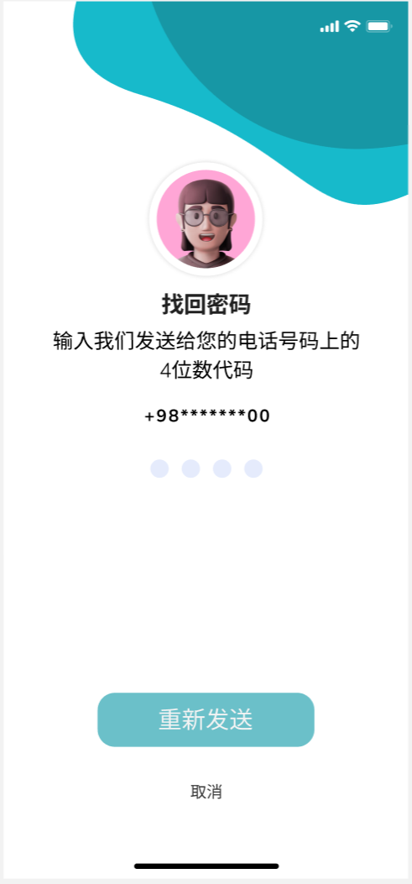

app:


- Gamepublisher类
signupOrdinaryUser.html | 玩家注册页面
Index.html | 首页

web:


app:
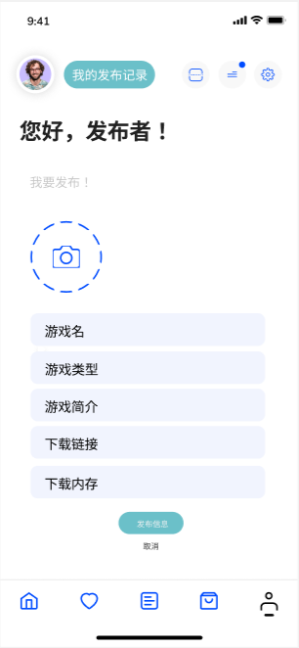
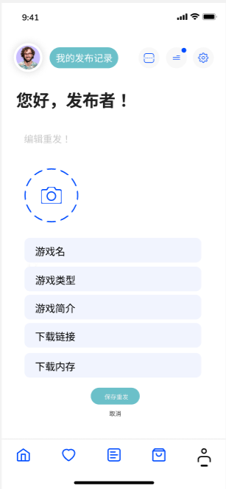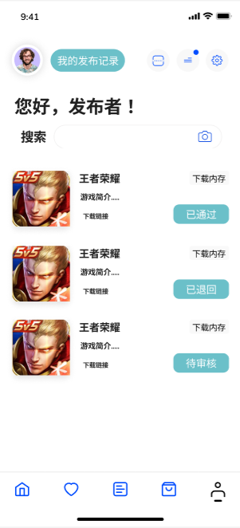

- Administrator类

manageUser.html | 管理用户账号页面
web:
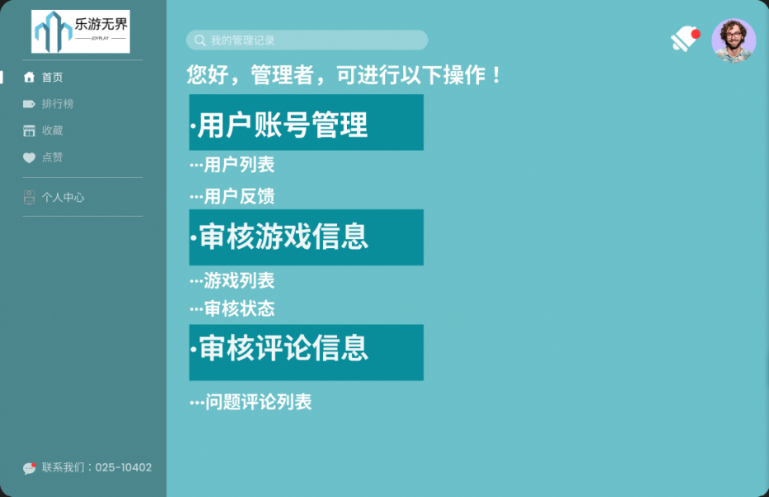

app:
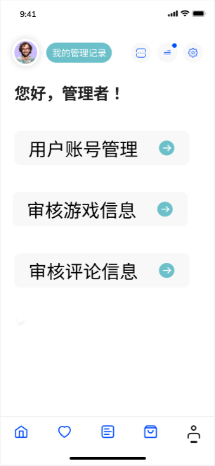

resultSearchUser.html | 查询用户结果页面
web:
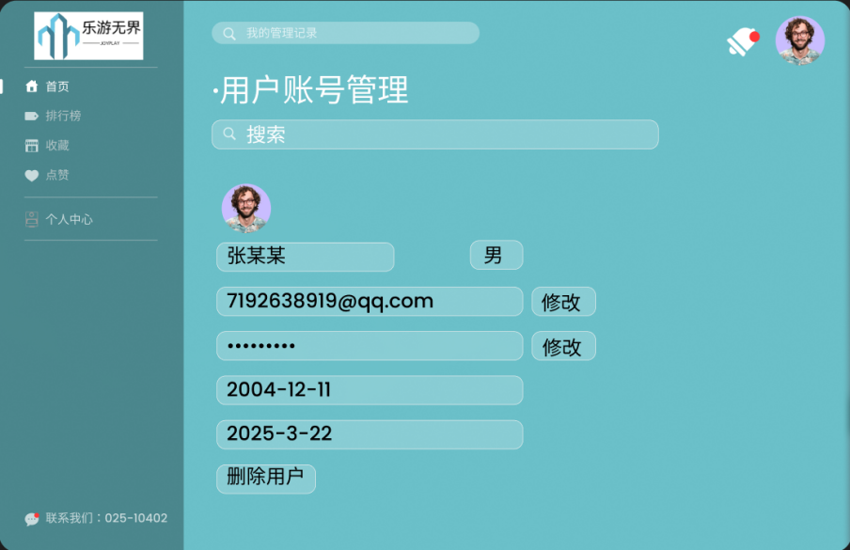
app:
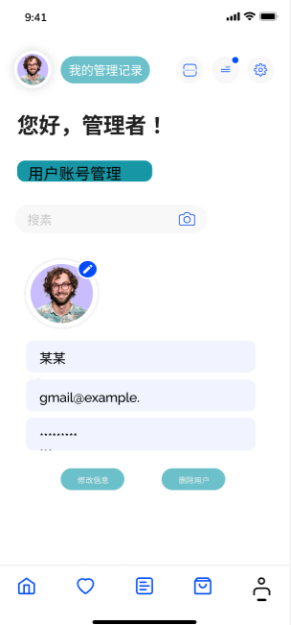
auditGameinformation.html | 审核游戏信息页面
web:
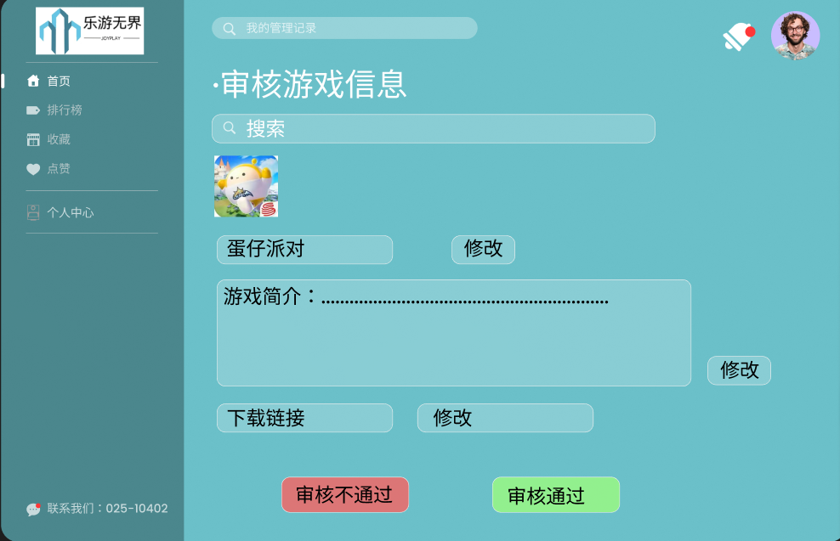
app:
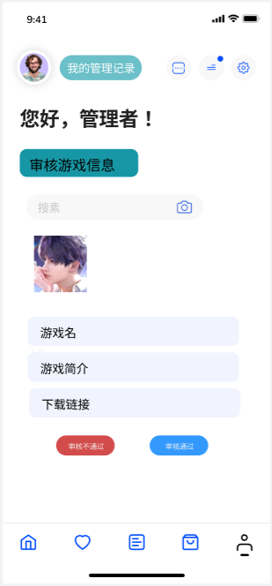
aduitcumment.html | 审核评论页面
web:
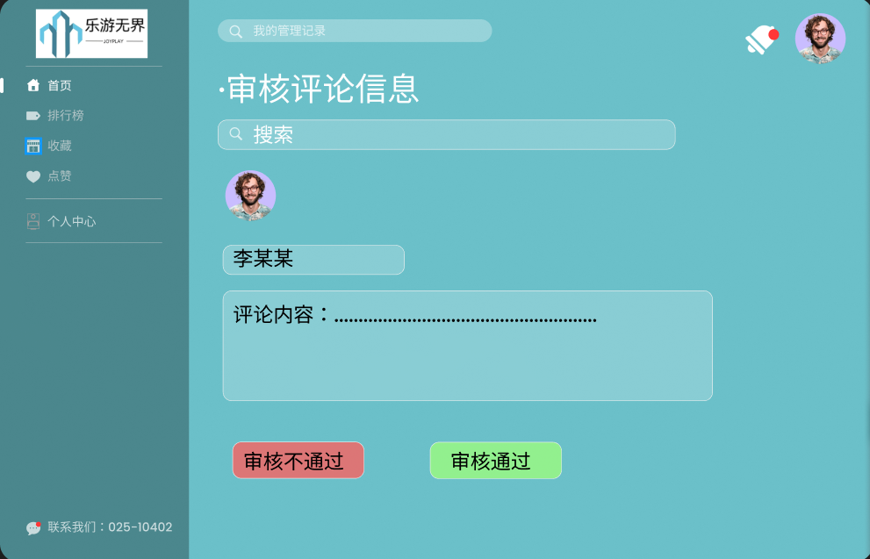
app:
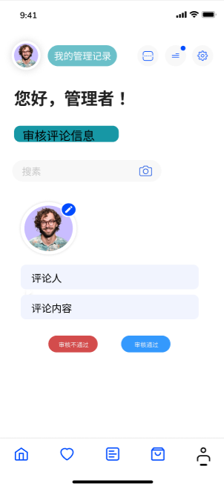
- Gameinformation类

AddGameinformation.html | 游戏信息发布页面
EditGameinformation.html | 编辑游戏信息页面
web:
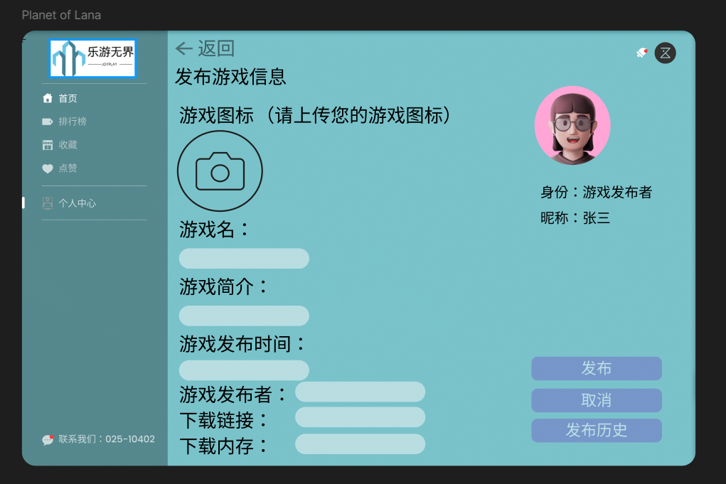
app:


MangeGameinformation.html | 管理游戏信息页面
web:
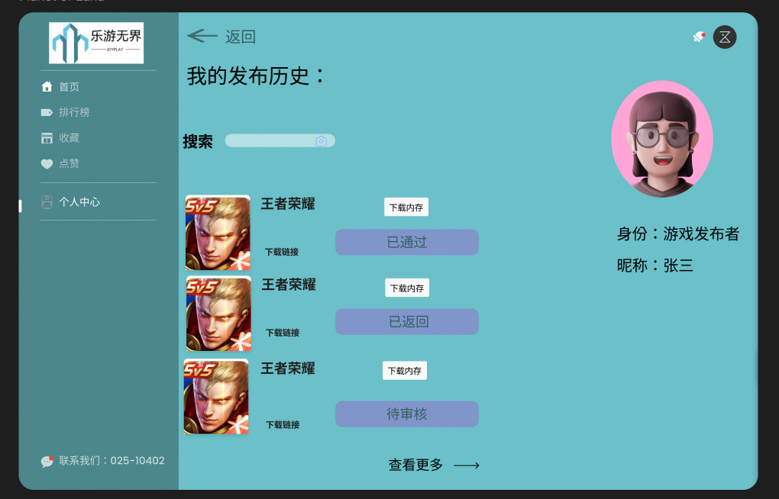
app:

SearchGameinformation.html | 查询游戏信息页面
web:

app:
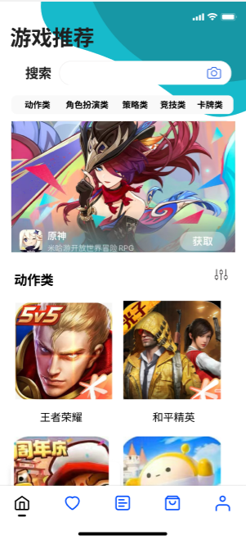

DisplayGameinformation.html | 游戏信息详情页面
web:
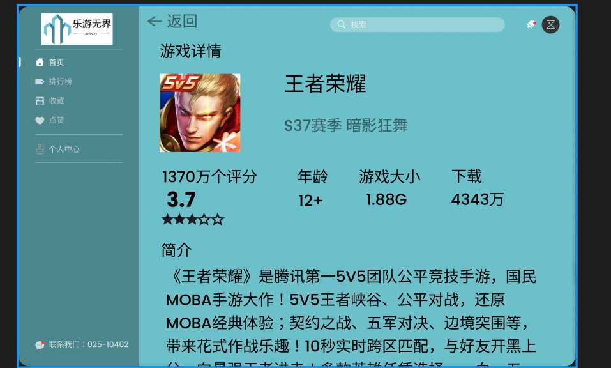
app:
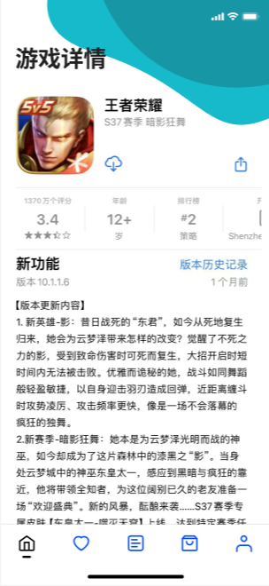

- Thumbsup类

ManageThumbsup.html | 管理点赞页面
CancelThumbsup.html | 取消点赞页面
web:

app:
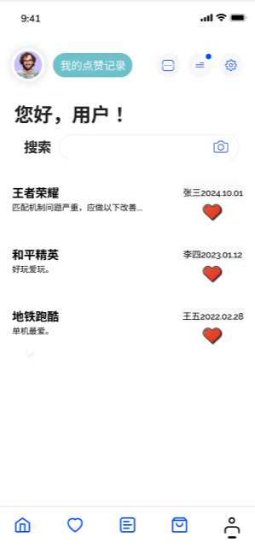

- Comment类

AddComment.html | 发布评论页面
SearchComment.html | 查询评论页面
EditComment.html | 编辑评论页面
DisplayComment.html | 评论详情页面
DeleteComment.html | 删除评论页面
web:
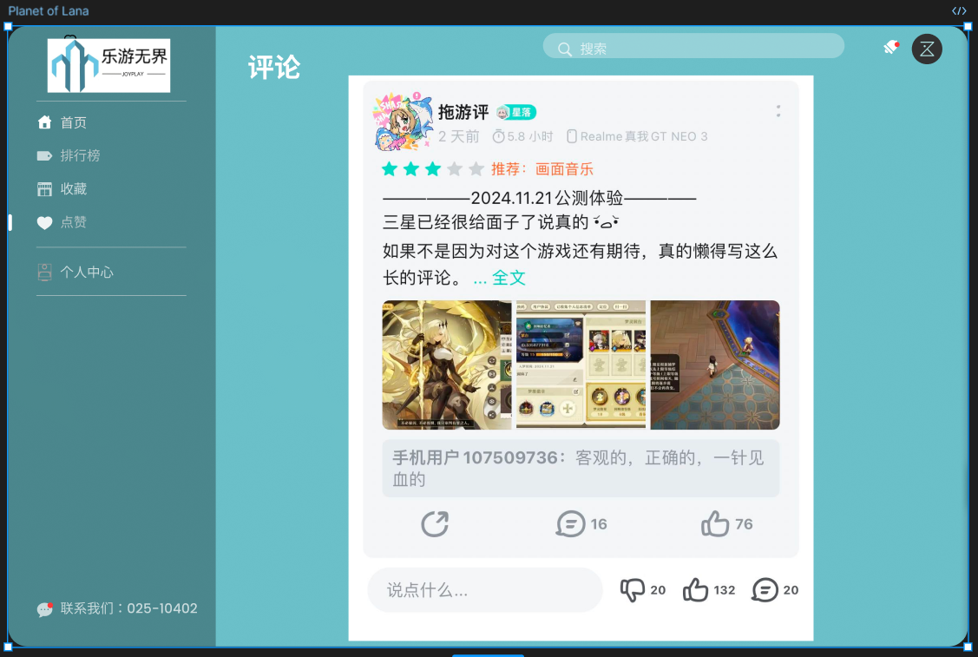
app:
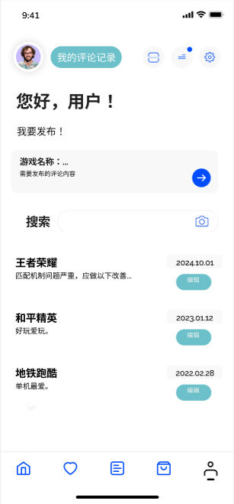

- Collect类

ManageCollect.html | 管理收藏页面
CancelCollect.html | 取消收藏页面
web:
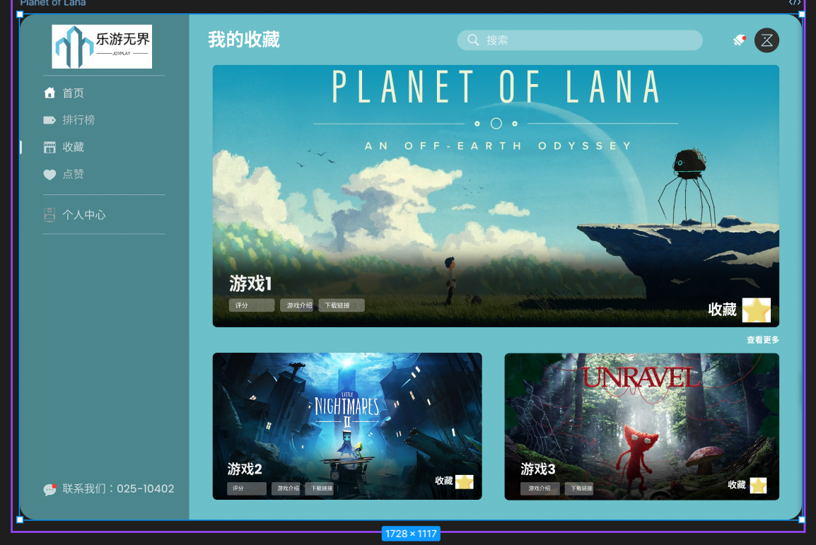

app:
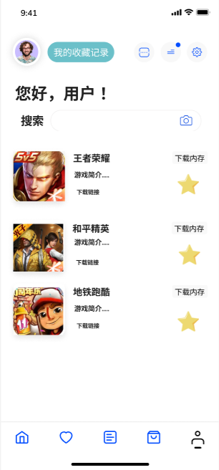

三、事务逻辑设计
1、Gameplayer类
登录处理
Procedure login
Begin
choose the method of login
If (choose the Account password login) then
get the usermailbox or phonenumber and userPassword from signin.html
find the usermailbox and password in the database
If (usermailbox not found ) or (usermailbox exist but inputPassWord != Password indatabase )then
display error hint
Else
goto index.html
End if
Else if (choose the SMS verification code login) then
get the phonenumber and the verification from signin.html
find the phonenumber in the database and check the verification
If (phonenumber not find) or (the verification is not correct) then
display error hint
Else
goto index.html
End if
End if
End login
注册处理
Procedure signup
Begin
get the new_user's info from signupOrdinaryUser.html
find the usermailbox or phonenumber in the database
If (the usermailbox or phonenumber existed in the database) then
show error hint
Else
send the verification to the user with SMS
get and check the verification from signupOrdinaryUser.html
If (the verification is not correct) then
show error hint and let the user try again
Else
add user's info to database
goto signin.html
End if
End if
End signup
修改个人信息处理
Procedure changeUserInfo
Begin
get the changed userinfo from changeUserInfo.html
find the user and the user's info in database
input the new info into database
goto getUserInfo.html
End changeUserInfo
修改密码处理
Procedure changepassword
Begin
get the originalpassword from changepassword.html
If the (inputpassword ==correct password in database) then
get two new_password which is inputted by the user twice
If (the two new_password is the same) then
find the user's info in the database
change the old_password into the new password
goto getUserInfo.html
Else
show error hint
End if
Else
show error hint
End if
End changepassword

忘记密码重置密码处理
Procedure forgetpassword
Begin
get the user's phonenumber from forgetpassword.html
find the user's phonenumber in the database
If (the user's phonenumber is existed) then
send the verification to the user with SMS
get and check the verification from forgetpassword.html
If (the verification is not correct) then
show error hint and let the user try again
Else
show the set_new_password page and let the user set the new password
get two new_password which is inputted by the user twice
If (the two new_password is the same) then
find the user's info in the database
change the old_password into the new-seted password\
goto signin.html
Else
show error hint and let the user try again
End if
End if
Else
show error hint
End if
End forgetpassword

注销账号处理
Procedure cancelUser
Begin
get the cancelUser submit from getUserInfo.html
show cancelUser.html
get the result from cancelUser.html
If (the reuslt is yes) then
find the user in database
cancel the user's account and set the account is non-existent in the database
goto signin.html
Else
return to getUserInfo.html
End if
End cancelUser

- Gamepublisher类
登录处理
Procedure login
Begin
choose the method of login
If (choose the Account password login) then
get the usermailbox or phonenumber and userPassword from signin.html
find the usermailbox and password in the database
If (usermailbox not found ) or (usermailbox exist but inputPassWord != Password indatabase )then
display error hint
Else
goto index.html
End if
Else if (choose the SMS verification code login) then
get the phonenumber and the verification from signin.html
find the phonenumber in the database and check the verification
If (phonenumber not find) or (the verification is not correct) then
display error hint
Else
goto index.html
End if
End if
End login
注册处理
Procedure signup
Begin
get the new_user's info from signupOrdinaryUser.html
find the usermailbox or phonenumber in the database
If (the usermailbox or phonenumber existed in the database) then
show error hint
Else
send the verification to the user with SMS
get and check the verification from signupOrdinaryUser.html
If (the verification is not correct) then
show error hint and let the user try again
Else
add user's info to database
goto signin.html
End if
End if
End signup
修改个人信息处理
Procedure changeUserInfo
Begin
get the changed userinfo from changeUserInfo.html
find the user and the user's info in database
input the new info into database
goto getUserInfo.html
End changeUserInfo
修改密码处理
Procedure changepassword
Begin
get the originalpassword from changepassword.html
If the (inputpassword ==correct password in database) then
get two new_password which is inputted by the user twice
If (the two new_password is the same) then
find the user's info in the database
change the old_password into the new password
goto getUserInfo.html
Else
show error hint
End if
Else
show error hint
End if
End changepassword

忘记密码重置密码处理
Procedure forgetpassword
Begin
get the user's phonenumber from forgetpassword.html
find the user's phonenumber in the database
If (the user's phonenumber is existed) then
send the verification to the user with SMS
get and check the verification from forgetpassword.html
If (the verification is not correct) then
show error hint and let the user try again
Else
show the set_new_password page and let the user set the new password
get two new_password which is inputted by the user twice
If (the two new_password is the same) then
find the user's info in the database
change the old_password into the new-seted password\
goto signin.html
Else
show error hint and let the user try again
End if
End if
Else
show error hint
End if
End forgetpassword

注销账号处理
Procedure cancelUser
Begin
get the cancelUser submit from getUserInfo.html
show cancelUser.html
get the result from cancelUser.html
If (the reuslt is yes) then
find the user in database
cancel the user's account and set the account is non-existent in the database
goto signin.html
Else
return to getUserInfo.html
End if
End cancelUser

- Administrator类
登录处理
Procedure login
Begin
choose the method of login
If (choose the Account password login) then
get the usermailbox or phonenumber and userPassword from signin.html
find the usermailbox and password in the database
If (usermailbox not found ) or (usermailbox exist but inputPassWord != Password indatabase )then
display error hint
Else
goto index.html
End if
Else if (choose the SMS verification code login) then
get the phonenumber and the verification from signin.html
find the phonenumber in the database and check the verification
If (phonenumber not find) or (the verification is not correct) then
display error hint
Else
goto index.html
End if
End if
End login
管理用户账号
Procedure manageUser
Begin
choose the fuction of manageUser part
If (use the fuction of search_user) then
get the userinfo which is inputted to search the user
find the user whose info is corresponded to the submitted
If (the user is existed in the database) then
show the search result
Else
show no search result hint
End if
Else if (use the function of change_user_info) then
show the designated user's concrete info
get the Specific manage operation and operate the database
goto manageUser.html
Else if (use the function of delete_user_info) then
get the Administrator's password
check the inputted password
If (the password is correct) then
delete the designated user and this user's info in the database
goto manageUser.html
Else
show error hint
End if
End if
End manageUser
管理员审核处理
Procedure Audit
Begin
choose the type of audit action
If (the action is auditGameinformation) then
auditGameinformation.html
choose the designated auditGameinformation.html info
get the submitted operation and perform operation
Else if (the action is auditcomment) then
goto auditcomment.html
choose the designated auditcommentinfo
get the submitted operation and perform operation
End if
End Audit

4、Gameinformation类
发布游戏信息处理
PROCEDURE publishgame
BEGIN
get the name,introduction,downloadlink,memorysize and gamekind from MangeVolunteerActivity.html
IF (name,introduction,downloadlink,memorysize or gamekind is empty )THEN
display error hint
ELSE
record the time of the submission --*record the time
goto Displaygameinformation.html
ENDIF
END publishgame

Procedure cancelUser

删除游戏信息处理
PROCEDURE deletegame
BEGIN
get the title from MangeGame.html
find the title in the database
IF (the title not found) THEN
display error message
ELSE
IF (the request is not submitted by the author) THEN
show error hint
ELSE
delete the Activity from the database
display success message
goto MangeGame.html
ENDIF
ENDIF
END deletegame

修改游戏信息处理
PROCEDURE modifyGame
BEGIN
get the title from MangeGame.html
find the title in the database
IF (the title not found) THEN
display error message
ELSE
IF (the request is not submitted by the author) THEN
show error hint
ELSE
get the name,introduction,downloadlink,memorysize and gamekind
IF (name,introduction,downloadlink,memorysize or gamekind is empty )THEN
display error hint
ELSE
record the time of the submission--*record the time
update the Game from the database
display success message
goto MangeGame.html
ENDIF
ENDIF
ENDIF
END modifyGame
5、Thumbsup类
点赞评论处理
Procedure Thumbsup
Begin
If(login()=true) then
Find the Comment
Enter the Comment
If(!Thumbsup) then
Click the Thumbsup
else
Return;
End if
End Thumbsup
取消点赞评论处理
Procedure CancelThumbsup
Begin
If(login()=true) then
Find the Comment
Enter the Comment
If(Thumbsup) then
Click theThumbsup
else
Return;
End if
End CancelThumbsup

6、Comment类
发布评论
Procedure PublishComment
Begin
If(Login() = true) then
Enter AddComment.html
Enter information
click submit
End if
End PublishComment

删除评论
Procedure DeleteComment
Begin
If(login() = true) then
If( find(Comment)!=false) then
click delete
End if
End if
End DeleteComment
7、Collect类
收藏处理
Procedure Collect
Begin
If(login()=true) then
Find the Game
Enter the Game
If(!collect) then
Click the collect
else
Return;
End if
End Collect
取消收藏处理
Procedure CancelCollect
Begin
If(login()=true) then
Find the Game
Enter the Game
If(collect) then
Click the collect
else
Return;
End if
End CancelCollect

四、数据库设计
1、Gameplayer类
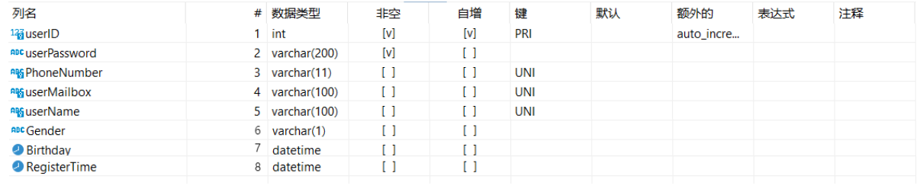
2、Gamepublisher类
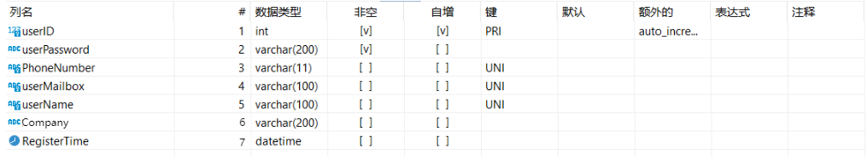
3、Administrator类
- Gameinformation类
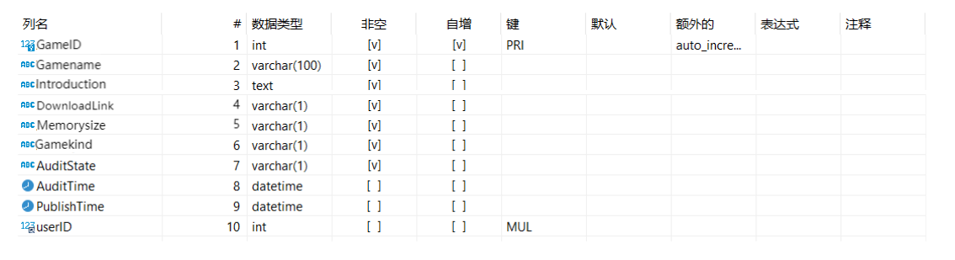5、Thumbsup类
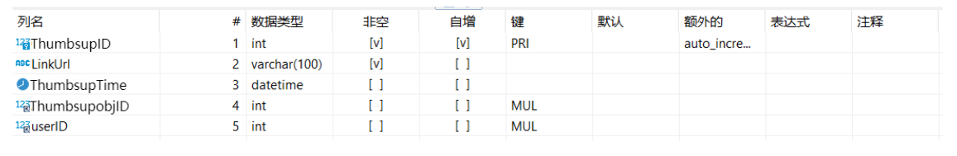
6、Comment类
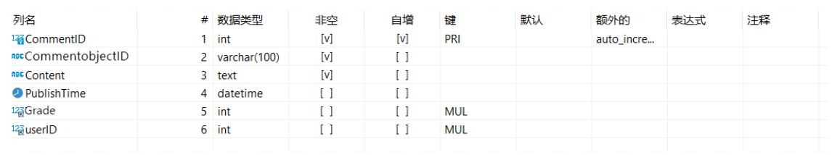
7、Collect类
